公禱文
The Book of Common Prayer in Chinese
Shanghai: Issued by the American [Episcopal] Church, 1932.
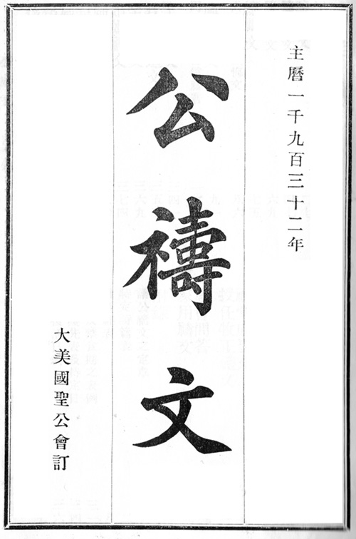
大美國聖公會訂
小引 |  | Preface [forthcoming]
早禱文 | 1 | Morning Prayer
晩禱文 | 27 | Evening Prayer
隨時禱文 | 47 | Prayers
隨時謝文 | 69 | Thanksgivings
總禱文 | 75 | Litany
大齋首日懴悔文 | 86 | Commination
施聖餐文 | 91 | Holy Communion
周年祝文書信福音 | 124 | Collects, Epistles and Gospels [forthcoming]
聖洗禱文 | 341 | Baptism
教会授道文 | 353 | Admission of Catechumens
堅振禱文 | 369 | Confirmation
婚姻禱文 | 374 | Matrimony
婦人生産後感謝文 | 380 | Thanksgiving of Women after Childbirth
問病人文 | 383 | Visitation of the Sick
施聖餐病人文 | 400 | Communion of the Sick
殯葬聖禮文 | 404 | Funeral
孩童殯葬禮文 | 420 | Funeral of a Child
詩篇 | 427 | The Psalter
派立會吏禮文 | 575 | Form and Manner of Making Deacons
派立會長禮文 | 583 | Form and Manner of Ordering Priests
派立主教禮文 | 597 | Consecration of a Bishop
派立聖職總禱文 | 611 | Litany for Ordinations
祝堂成聖文 | 615 | Consecration of a Church
授任牧正禱文 | 621 | Order of Institution
教會問答 | 629 | Catechism
家用禱文 | 639 | Family Prayers

Notes on the digital edition
The text of this Chinese translation of the American Book of Common Prayer is presented here as page images saved in Portable Document Format. The Psalter has been omitted. This edition is not included in David N. Griffiths's Bibliography of the Book of Common Prayer 1549-1999; earlier Prayer Book translations into Chinese are discussed in William Muss-Arnolt's Book of Common Prayer among the Nations of the World, Chapter XL.
The Preface—dated June, 1932—is signed by Logan Herbert Roots (吳德施, 1870-1945, II Bishop of Hankow), Frederick Rogers Graves (郭斐蔚, 1858-1940, V Bishop of Shanghai), and Daniel Trumbull Huntington (韓仁敦, 1868-1934, I Bishop of Wuhu).
Helen Gordon, Cynthia McFarland and Brian Reid provided technical support for the digitization process. Thomas N. Rae provided a copy of the book, which belonged originally to American medical missionary William Winston Pettus (1912-1945).

http://www.mammana.org/bcp/chinese/shanghai1932/

